**National Textile University, Faisalabad**



**Department of Computer Science**

|  |  |
| --- | --- |
| **Name:** | Fareena Shahbaz |
| **Class:** | BSCS 5th _A |
| **Registration No:** | 23-NTU-CS-1024 |
| **Course Name:** | Embedded IoT Systems |
| **Submitted To:** | Sir Nasir Mahmood |
| **Submission Date:** | 26/10/2025 |

Assignment#1

Contents

**TASK-A** 3

**Wokwi Project Link:** 3

**Objective** 3

**Hardware Components** 3

**Working Principle** 3

**System Behavior** 3

**Features** 4

**Expected Output** 4

**Summary** 4

**ScreenShots:** 4

**TASK-B** 7

**Short & Long Press with OLED Feedback** 7

**Wokwi Project Link:** 7

**Objective** 7

**Hardware Components** 7

**Pin Configuration** 8

**Logic Explanation** 8

**Functions Description** 9

**OLED Display Messages** 9

**Flow Summary** 9

**Key Features** 10

**Expected Output** 10

**Summary** 10

**ScreenShots And Working:** 11

# **TASK-A**

**Simple LED Toggle with OLED Display**

### **Wokwi Project Link:**

<https://wokwi.com/projects/445497187511394305>

### **Objective**

To implement a **basic LED control** using a **push button** with visual feedback on an **OLED display**.

### **Hardware Components**

|  |  |
| --- | --- |
| **Component** | **Description** |
| **ESP32** | Microcontroller |
| **Push Button** | Used to toggle LED |
| **LED** | Indicates state (ON/OFF) |
| **OLED (SSD1306)** | Displays current LED state |

**Working Principle**

1. Button is connected using **internal pull-up resistor**.
2. When pressed (LOW), it toggles the LED state.
3. OLED updates message to show **“LED ON”** or **“LED OFF”**.

### **System Behavior**

|  |  |  |
| --- | --- | --- |
| **Action** | **LED State** | **OLED Message** |
| Initial | OFF | “LED OFF” |
| 1st Press | ON | “LED ON” |
| 2nd Press | OFF | “LED OFF” |

### **Features**

* Debounced button press detection.
* Real-time OLED message updates.
* Simple LED toggling logic for beginners.

### **Expected Output**

* Pressing the button toggles LED.
* OLED correctly shows **LED ON / LED OFF**.
* Serial monitor logs events like “LED ON” or “LED OFF”.

### **Summary**

|  |  |
| --- | --- |
| **Action** | **Output** |
| Button Press | LED toggles |
| OLED | Displays LED state |
| Serial Monitor | Shows debug messages |

### **ScreenShots:**

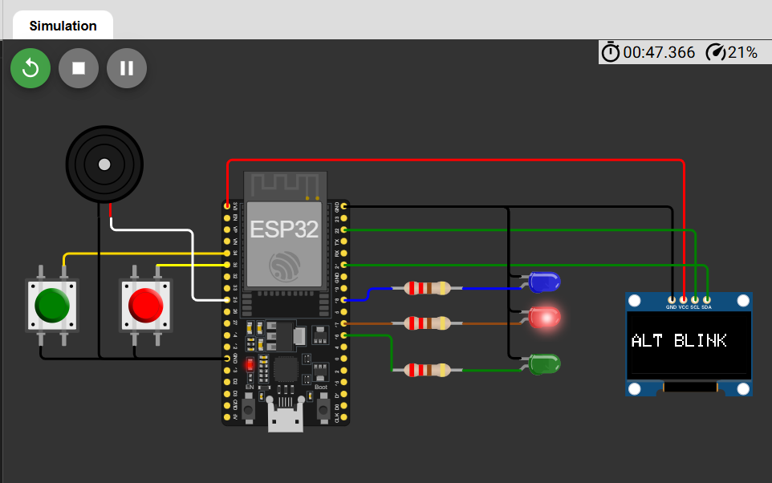

# **TASK-B**

## **Short & Long Press with OLED Feedback**

### **Wokwi Project Link:**

<https://wokwi.com/projects/445804337034818561>

### **Objective**

To implement **button press duration detection** on ESP32.

* A **short press** toggles the LED state (ON/OFF).
* A **long press (more than 1.5 seconds)** plays a **buzzer tone**.
* The **OLED display** updates messages according to the current system state.

### **Hardware Components**

|  |  |
| --- | --- |
| **Component** | **Description** |
| **ESP32** | Main microcontroller |
| **LED** | Visual indicator for short press action |
| **Buzzer** | Emits tone for long press |
| **Push Button** | Used to trigger actions |
| **OLED (SSD1306)** | Displays system messages |

### **Pin Configuration**

|  |  |
| --- | --- |
| **Component** | **ESP32 Pin** |
| LED | GPIO 18 |
| Button | GPIO 34 |
| Buzzer | GPIO 25 |
| OLED SDA | GPIO 21 |
| OLED SCL | GPIO 22 |

### **Logic Explanation**

1. **Button Press Detection:**
   * The button is connected with an **internal pull-up resistor**, meaning it reads **HIGH** when not pressed and **LOW** when pressed.
2. **Debouncing:**
   * To avoid noise in mechanical button presses, a **50 ms delay** (DEBOUNCE_DELAY) is used.
3. **Press Duration Calculation:**
   * When the button is pressed, pressStartTime is recorded using millis().
   * On release, the total duration is checked.
4. **Short Press Action:**
   * If the duration is **less than 1.5 seconds**, the LED toggles its state (ON ↔ OFF).
   * The OLED displays **“LED ON”** or **“LED OFF”** accordingly.
5. **Long Press Action:**
   * If the duration is **more than 1.5 seconds**, the **buzzer plays a tone** at 1000 Hz for 500 ms.
   * The OLED displays **“BUZZER ON”** temporarily.

### **Functions Description**

|  |  |
| --- | --- |
| **Function** | **Purpose** |
| updateOLED(const char *msg) | Clears OLED and displays a new message (like “LED ON” or “BUZZER ON”) |
| playBuzzerTone() | Plays a 1000 Hz tone for 500 ms using tone() |
| loop() | Detects button press, determines press duration, and executes actions accordingly |
| setup() | Initializes all hardware components (OLED, button, LED, buzzer) |

### **OLED Display Messages**

|  |  |
| --- | --- |
| **Event** | **Display Message** |
| System Start | LED OFF |
| Short Press (LED ON) | LED ON |
| Short Press (LED OFF) | LED OFF |
| Long Press | BUZZER ON |

### **Flow Summary**

1. Button Pressed → Time Recorded
2. If released quickly → Toggle LED
3. If held long → Play Buzzer
4. OLED updates messages accordingly

### **Key Features**

* Uses **non-blocking** timing via millis() instead of delay() for press detection.
* Displays **real-time feedback** on OLED.
* Implements **software debouncing**.
* Demonstrates **multi-peripheral coordination** on ESP32.

### **Expected Output**

* **Short Press:** LED toggles ON/OFF, OLED shows LED state.
* **Long Press (>1.5s):** Buzzer plays tone, OLED shows “BUZZER ON”.

### **Summary**

|  |  |
| --- | --- |
| **Action** | **Result** |
| Short Press | LED toggles |
| Long Press | Buzzer plays |
| OLED | Shows feedback for every action |
| Serial Monitor | Logs button events and actions |

### **ScreenShots And Working:**



